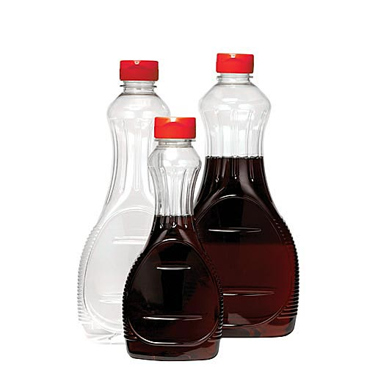
PEER EDITITING
SYRUP LOGO: BRAND MASCOT PROJECT

Switch computers with another student. Complete this sheet on his/her computer. SAVE. Upload FILE to Weebly after you make changes and upload your finished logo.
- What era do you think this logo represents?
Either the 50’s or 60’s
- What design choices did the student make to represent their era? (hair style, colors, fonts, prints or patterns, etc.)
The filter on the mascot is represented as being older as well as the colors being of around the era
- Are ALL logo project requirements fulfilled?
I think that all of the requirements are fulfilled, typing on a path, clipping mask, image adjustments, and blending adjustments are all present on the label.
- Do you think the logo looks finished? Why or why not.
To an extent the label looks finished and is ready to be on a bottle
- What do you like about the logo?
I like the borders of the label as it clearly represents qualities of syrup
- What tools do you see that the student used?
A clipping mask, drop shadow effect, filter
- What suggestions do you have for this student? Is there anything you would add or change to make the logo look more professional? What are some other tools or pieces that can be added to make the most of Photoshop tools?
I don’t think that much more can be used to make this any more professional as it looks like it used all the tools to make a quality label
Peer editor: Matt Graca

